To meet the needs of teachers,
U.S. and Morocco focus on online training
Tech initiative is an expansion of USAID-supported
Higher Education Partnership-Morocco.
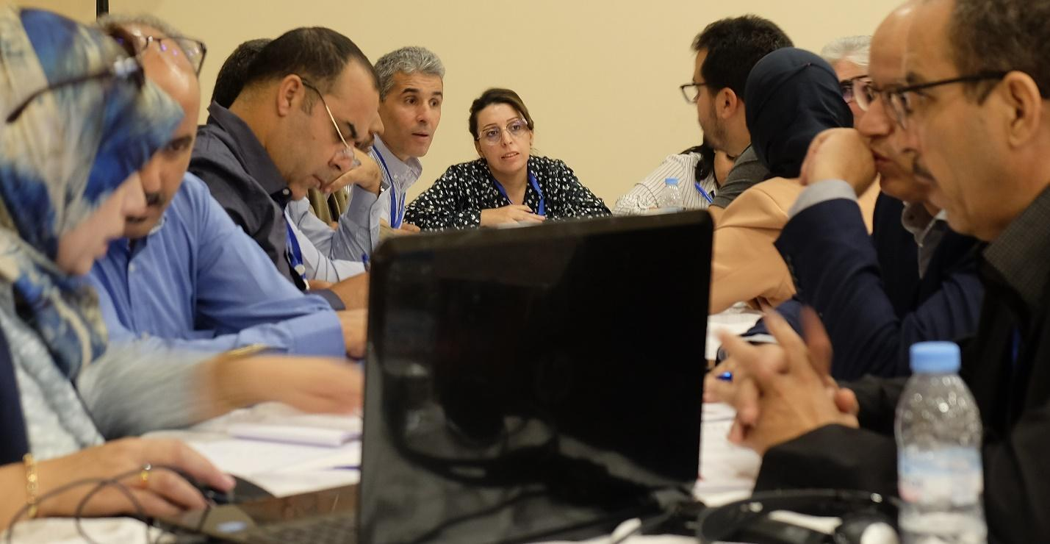
Instructors from various teacher-training institutions across Morocco gathered in Marrakesh Nov. 9–12, 2022, under a new initiative for online training for elementary school teachers, supported by USAID. (Photo by Daniel Lynx Bernard for ASU)
By Daniel Lynx Bernard — Dec. 17, 2022
As Morocco strives to increase its workforce of school teachers, the U.S. is helping faculty who prepare Moroccan teachers to leverage technology to train future teachers anywhere, anytime. This November, the U.S. Agency for International Development, or USAID, and the government of Morocco began a $1 million, two-year activity to strengthen the use of technology to train teachers remotely and at scale.

Building on existing cooperation to strengthen teacher training under the Higher Education Partnership-Morocco, or HEP-M, the partners convened more than 250 educators in Marrakesh for a series of training workshops led by Arizona State University. Over four days, deans and professors from Moroccan universities joined directors and instructors from government teacher training centers for participatory trainings on international best practices in online course design.

Participants worked energetically in groups to draft strong structures for courses that can engage users and meet their learning needs. The workshops introduced participants to a framework for designing online learning content to meet international quality standards, such as clear navigation, active learning, and activities and assessments that match what teacher trainees are expected to learn. The training underscored the importance of universal design for learning, which acknowledges and supports users’ diverse approaches to learning by creating online learning experiences that are accessible to all.
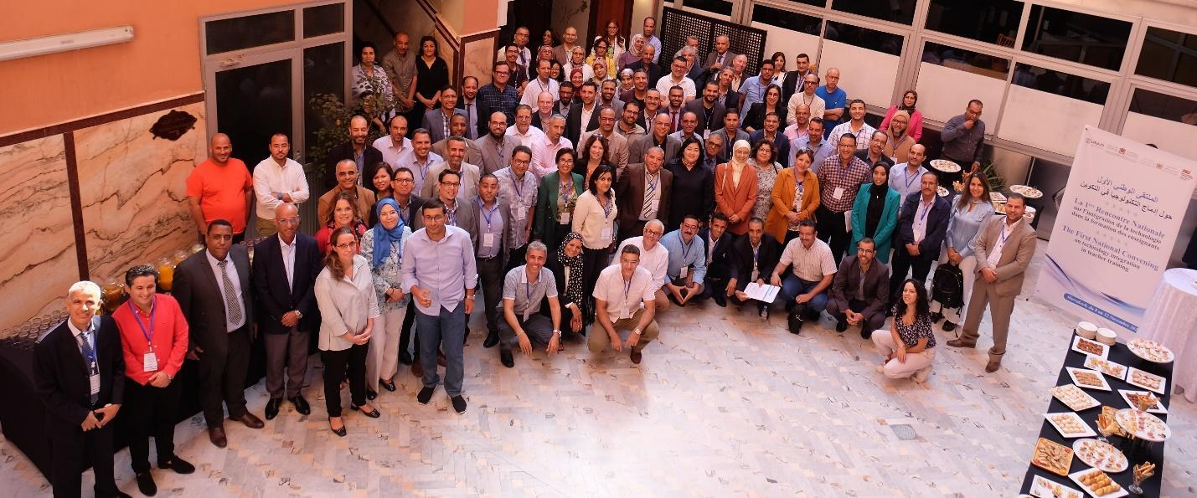
Instructors from universities and government training centers around Morocco gathered in Marrakesh Nov. 9–12, 2022, for the First National Convening on Technology Integration in Teacher Training, part of the USAID-supported Higher Education Partnership-Morocco, or HEP-M. (Photo by Daniel Lynx Bernard for ASU)
Participants said they obtained insights and reviewed resources at the workshops that they plan to apply in their design of online educational content. Yousra Kadi, a professor who prepares future teachers at the Superior School of Education and Training, or ESEF, at University Sultan Moulay Slimane in Beni Mellal, said the training gave her a new appreciation of the need, “to include a mix of methods in my teaching to make my class diverse and unpredictable.”

Kadi continued, “When you use other methods, your class will be more entertaining, more engaging and you will also cover your students’ needs. Some are social by nature. This is the most interesting part: Even in online teaching, we can create teamwork activities.”

The new resources and skills will help Morocco respond to urgent demographic shifts: a surging youth population when experienced teachers are retiring. At the same time Morocco has recognized the urgency of increasing teachers’ competencies especially at the primary school level in order to improve students’ learning outcomes.

HEP-M is funded by USAID and implemented by ASU’s Mary Lou Fulton Teachers College. The project facilitates cooperation between Morocco’s two education ministries: the Ministry of Higher Education, Scientific Research and Innovation, which oversees teaching colleges; and the Ministry of National Education, Preschool and Sports, which oversees the pre-service preparation of teachers. Under HEP-M, educators under both ministries have been working together since 2019 to upgrade teacher-training curricula to global standards. The ministries requested the addition of the technology initiative in recognition of the rapid progress made under HEP-M.

Addressing the convening in Marrakesh, Noureddine El Mazouni, deputy director in charge of pedagogical training at the Ministry of National Education, thanked USAID and ASU for the initiative. “This National Convention on Technology Integration in Teacher Training which is starting today will be a starting point in order to implement these aspirations,” El Mazouni said. “This is crucial for the improvement of the professional performance of the different educators so that they can go hand in hand with the advances that are taking place in the digital world.”

El Mazouni said the educators trained under the initiative will serve as core experts in their respective regions ensuring high quality in distance education.

Ilham Morino, head of the Division of Non-University Higher Education Institutions within the Ministry of Higher Education, noted that the new initiative builds on the ongoing cooperation under HEP-M. “This is an opportunity to celebrate the excellent cooperation between Morocco and the U.S. in this comprehensive approach to preparing the teachers of the future and enabling them to have the qualifications necessary to meet the needs of students in their schooling,” Morino said. “We will continue to work eagerly and earnestly with USAID in order to push forward this important project in order to ensure that it achieves its goals.”
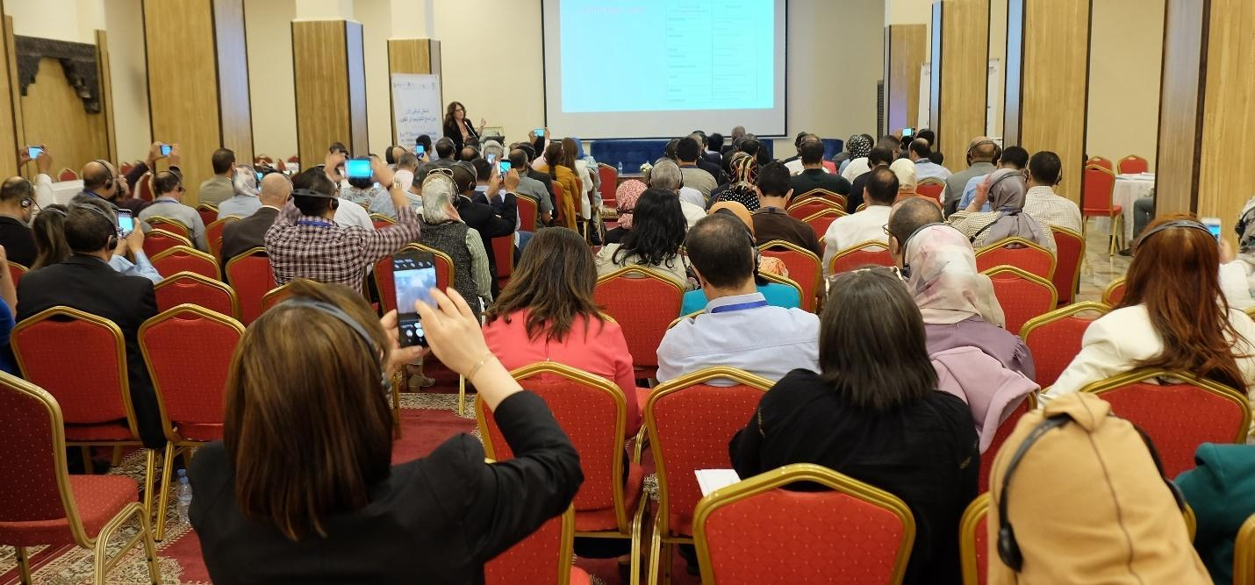
Attendees at the HEP-M workshop in Marrakesh photograph a presentation about the “flipped learning” method by Cindi Chang, adjunct professor at Touro University Nevada, on Nov. 12, 2022. (Photo by Daniel Lynx Bernard for ASU)
Workshop participant Prof. Mostafa Hamse, from the regional teacher training center (CRMEF) in Casablanca, said distance education is the right tool for Morocco to meet the challenge facing its teacher-preparation system. “It responds to the problem of mass scale-up,” Hamse said. “We have more demand from the standpoint of human resources, but we have less means from the standpoint of infrastructure. So, we really need these tools, above all distance learning, to respond to this need for scale-up for the great numbers coming each year. It’s a step forward, from a structural point of view. From a functional standpoint, distance education can be a powerful means to respond to teachers’ needs for continuing education.”

Professor Youssef Nait Belaid of University Mohammed V in Rabat said the initiative is an important milestone for the development of teacher preparation in Morocco. “Technology promotes active pedagogies, allowing project-based and collaborative learning among students and between them and their teacher,” Nait Belaid said. “The Marrakesh meeting on the integration of technology in teaching is an important step in the history of teacher training in Morocco. The workshop allowed us to see how technology can support the implementation of lessons from the planning of objectives to the results obtained.”

Professor Amal Rifai, a teacher trainer at the CRMEF in Rabat and an expert in distance learning platforms, said the capacity-building provided under HEP-M will be helpful to teacher trainers who have not yet been formally trained on the design of online learning. “For people who haven’t had a strategic approach to carrying out a distance education course before, they will reap benefits from this project.”

After building teacher trainers’ capacity in digital course design, the HEP-M technology initiative will support the teacher trainers in creating a set of massive open online courses, or MOOCs, for future primary-school teacher preparation. The capacity-building under the technology initiative will prepare the faculty to eventually develop a complete set of MOOCs to train primary-level teachers in all subjects.

The MOOCs can be used by trainers and trainees at any time as standalone online resources, or they can be incorporated by teacher trainers to supplement face-to-face training. The MOOCs will also be ideal for teachers who have already begun to work in the classroom but would benefit from a refresher. “This gives a way for them to go back and review content as needed,” said ASU Vice Dean of Teacher Preparation Nicole Thompson.

